1. Meeting Location: Teachers Pet Preschool - Welcome & Introductions
   1. Members Present:
      1. Darius Kalvaitis, ECE
      2. Wendy Jones, CDC
      3. Judi Anderson, HCOE
      4. Claire Knox, HSU
      5. Kristi Alberti, CECMP
      6. Star Mohat, 1st Five & 0-8
      7. Kathy Vitae, Teachers Pet Preschool
2. Groups
   1. Early Childhood Education at CR
   2. Child Development Training Consortium (CDTC)
   3. Career and Technical Education (CTE)
      1. Perkins Grant CTEA
      2. Strong Workforce Grant
3. ECE
   1. Semester Recap
      1. Week of the Young Child events (2nd annual). Strong collaboration between ECE and CDC at CR
   2. Commencement May 13- Same as HSU
   3. Summer/Fall/Spring
      1. Summer courses include: ECE 2 Online, ECE 7 live
      2. Fall and Spring courses available to students via OneReg now
4. CDTC
   1. Permit Matrix in review for changes
   2. Wendy Joined as Co-coordinator this year and will also be co- coordinator next year
   3. Budget $, Textbooks, Supplies, Payments to Students
      1. No Changes from last year. Same as previously.
5. CTE
   1. Skill building discussion. The group identifies areas including:
      1. Writing skills/research skills – how to do basic research and writer ups by students
      2. Understanding permit requirements & the “vow of poverty” in ECE
      3. Professional growth – push students to have more education
      4. Communication skills – to work better with adults and parents
      5. Link profession with what we do- use trainings and trends in the classroom – IE – Trauma informed trainings – so children do not get lost in the cracks
      6. Deal with challenging behaviors – need more CR courses to address this – Skills for behavior management – Chris Titus had the same idea previously. CR students are seeing more children with IEPs. Now 22% of children have IEPs.
   2. Perkins Grant
      1. 2016-2017 Completed –End of Technology cycle
         1. Classroom technology (Learning Genie DRDP full implementation) - and projector, laptops, iPad etc. for classroom. ECE 10 used this technology as a lab site. We are the first lab school doing this statewide with ECE students.
         2. Some PD funds were used for ECE Textbooks. $4500 we spent on the CDC lending library for students to check out textbooks.
      2. 2017-2018 Application under Review (Meeting with Dean and Budget coordinator led to 2 items removed due to eligibility criteria)
         1. Update ECE Materials & Communication. Funds requested for Darrius K, Wendy J and Michelle H. to do this work next fall.
         2. Partner with HCOE (Cindi Kaup) & TK Teachers. Expand placements at HCOE TK sites. This could cause a load on placement sites unless done. )-8 workforce permit.
         3. Increase engagement – Ukulele & PA Music Purchase
         4. PD for Faculty, Associate Faculty & Mentor Teachers – same as previous years. If faculty or mentor teachers would like PD, just ask.
6. Strong Workforce Grants
   * 1. Regional Project - ECE Technology Integration
        1. Year 1 $36,000 in pucrases for classroom, student and faculty, Master Teacher equipment and training. This is going well in year #1.
        2. Working with Butte and Shasta Colleges – Video conference next weeks. Classroom upgrades coming soon.
        3. Year 2 dependent on FTE growth. We need to ensure classes are not cancelled and we have completers.
     2. Local Project - Growing your own Teachers
        1. Partner with HSU and HCOE to develop additional pipeline to Special/Elementary Education Associates for Transfer Degree. Meeting regularly with HSU on this.
           1. AP 4020 (Intent to start a new program has begun – Taskforce being developed for review and possible approval)
        2. HSU Collaboration - Possibility of developing 4 courses that align with HSUs and HCOEs goals. CRs administration are in support and encouraging this. VP- Angelina Hill and President – Keith Snow-Flammer. We can sue the same courses we have including: ECE 2, ECE 7, ECE 10 and just need to develop a new course. ED 1 (Introduction to Education)
7. Community Update
   1. Mental Health Month is ongoing. Foe children and families.
8. HSU Child Development Update
   1. New Dean – Dr. Sing will be joining in July
   2. Working on Special Ed Grant
   3. Feelers out on some things
   4. Nasty budget issues at HSU. Lack of CD faculty.
   5. CD did not have enrollment decline (as other programs did)
   6. Just finished 5 yr. program review
   7. Take stress of the labs – creative alternatives for placements
   8. Moving away from textbooks and using electronic publishing for lab manuals etc.
9. Mentor Program Update
   1. See Handouts – attached
   2. Looking to recruit new mentors
   3. 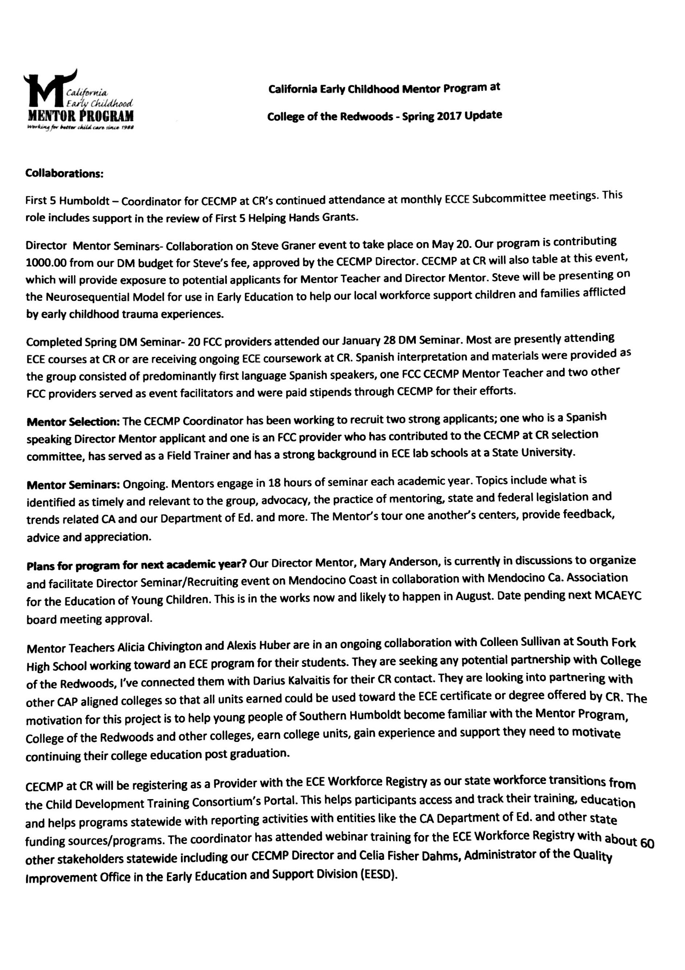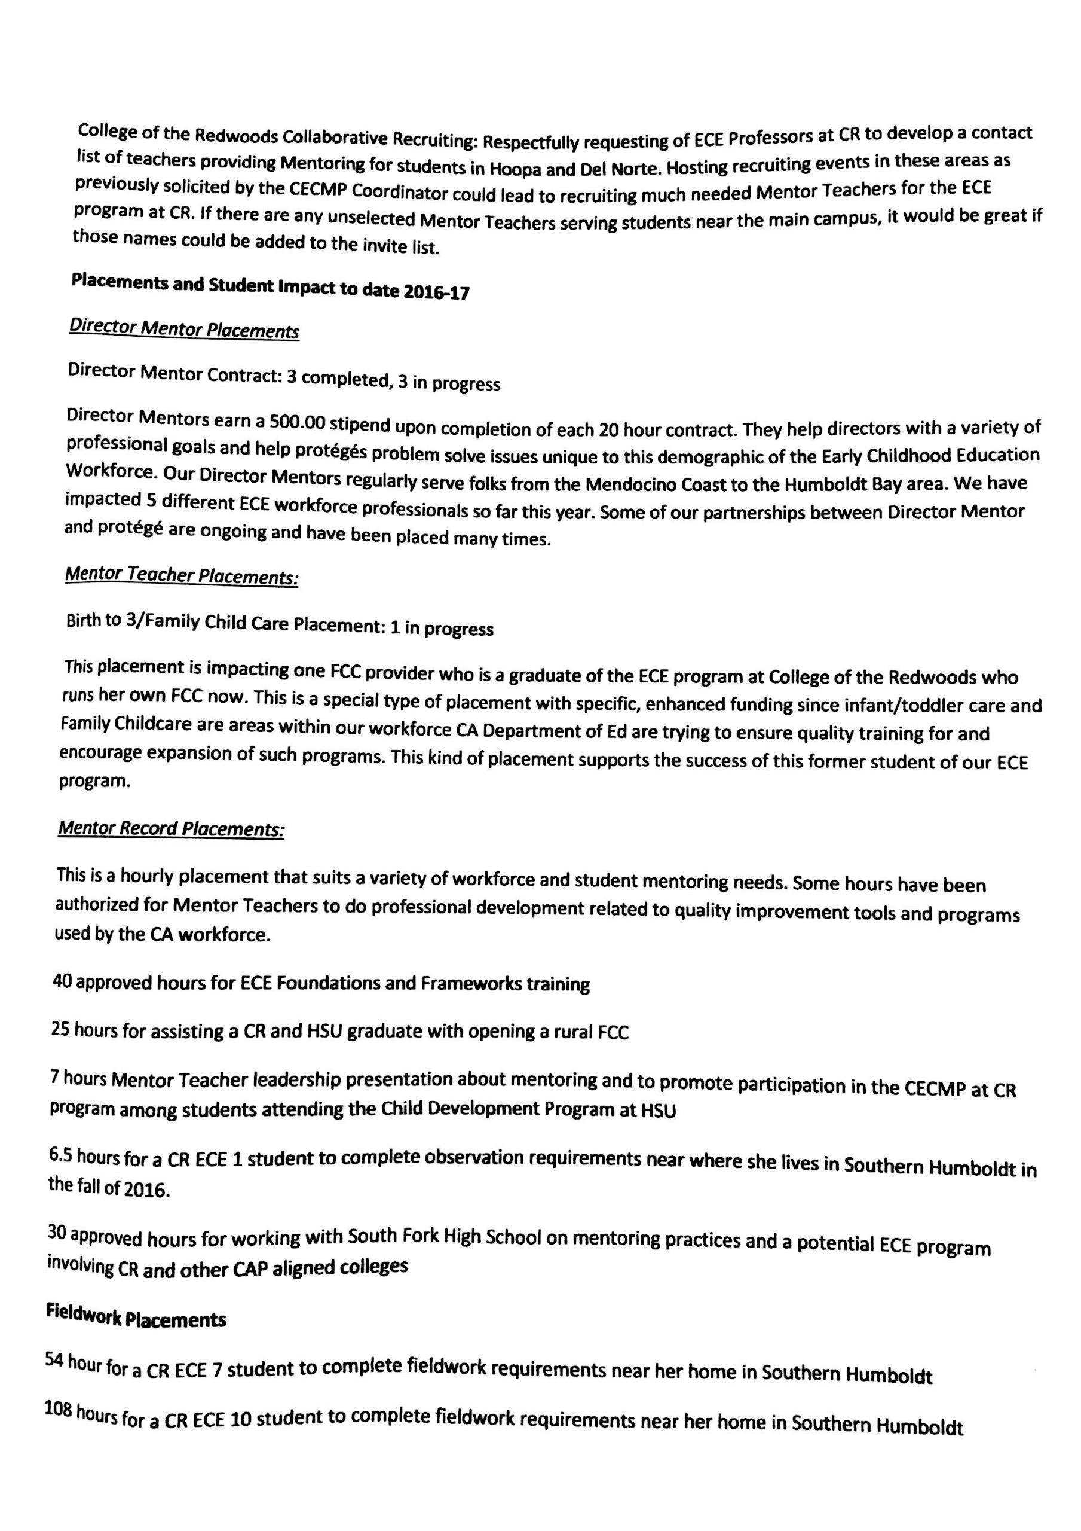
10. HCOE Update
    1. New superintendent – Chris Hartley. Not sure how this will impact ECE? Gary will be a hard act to follow and was a big supporter of ECE.
11. Closing